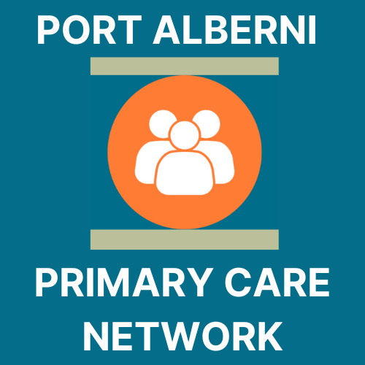
Port Alberni Primary Care Network
Nurse in Practice Manual

ACKNOWLEDGEMENTS
We want to acknowledge that our place of work is within the ancestral, traditional and unceded territory of the Tseshaht and Hupacasath people. We acknowledge this land out of respect for the ancestors of this place and reaffirm our relationship with one another in our work going forwards, together.
In addition, a special thanks goes to all teams that dedicated their time to this program:
- Physicians, Nurse Practitioners, RNs and MOAs
- First Nations, Métis, and Inuit Partners
- The Central Island Division of Family Practice
- Island Health
- First Nations Health Authority

Acronyms/Abbreviations
MOA | Medical Office Assistant
EMR | Electronic medical record
PCN | Primary Care Network
DoBC | Doctors of BC
CIDFP | Central Island Division of Family Practice
NIP | Nurse in Practice

This manual has been developed to assist in onboarding RNs in practice to Primary Care Networks.

First edition published in November 2023. See anything that is out of date or needs revision? Please contact PCN Administrator _________________

CLINIC INTRODUCTION

Contact Information & Clinic Information
Address:
Office telephone:
Office fax:
Office hours:

Call-in Procedures
Who do I report to if I am sick? Your first call should be to your clinic to let them know you are sick. Please also alert Island Health Staffing. A relief nurse may be organized to cover your practice if needed.
Can I work from home? You may be able to arrange days when you work from home, so long as this is supported by your clinic and Island Health Manager.

Clinic Staff
Physician/Nurse Practitioner:
Phone: Email:
Clinic Staff/MOA:
Phone: Email:

TABLE OF CONTENTS
ACKNOWLEDGEMENTS 2
Acronyms/Abbreviations 2
CLINIC INTRODUCTION 3
Contact Information & Clinic Information 3
Call-in Procedures 3
Clinic Staff 3
TABLE OF CONTENTS 4
PROGRAM INTRODUCTION 6
WHAT IS A PCN? 7
What are the benefits of a PCN? 7
Who’s who within the PCN? 7
ORIENTATION 8
TRAINING SCHEDULE 9
NIP SCOPE CHECKLIST 10
NIP COMPETENCY TRIANGLE 12
ISLAND HEALTH COURSES 13
PATHWAYS 17
Pathways Training 18
OTHER RESOURCES 19
QUICK REFERENCE 20
Record of Amendments 21
APPENDIX A: ENCOUNTER CODES 22
APPENDIX B: ENCOUNTER RECORD AUTHORIZATION 26
APPENDIX C: APPLICATION FOR BILLING NUMBER 27
APPENDIX D: MEDACCESS INTRODUCTION 28

PROGRAM INTRODUCTION
In March 2023, the BC Ministry of Health approved the Port Alberni Primary Care Network (PCN) service plan. The service plan contained 5 strategies to address the problems highlighted through widespread community consultation in 2021 as the main issues with accessing healthcare. The plan was written by a team made up of Central Island Division of Family Practice employees and members, Indigenous partners, and Island health employees. All groups consulted validated the plan.
This service plan includes the following 5 strategies to increase access and quality of primary care in Port Alberni:
- Community Health Centre, located in the city, creating low barrier, culturally safe access to team based care for Port Alberni’s most marginalized population of people. This health centre combines the social determinants of health approach of a community health centre with the traditional and culturally safe attributes of an Indigenous primary care centre.
- MHSU Clinic, located inside the Community Health Centre. This low-barrier MHSU clinic will act as an allied health hub, with the capacity to take referrals for attached patients from other primary care providers. This will increase access to quality MHSU services and create attachment capacity.
- Mobile Healthcare Unit, transportation barriers to accessing care for urban, rural and remote populations are widespread. There is a significant need to deliver mobile primary care services to these patients. This service strategy seeks to support our priority populations including urban Indigenous and non-Indigenous, rural and remote, as well as those who are street-entrenched.
- At 780 members, Métis represent a growing population. The MHA will support Métis clients, advocating for health provider relationships that are trauma-informed, patient and family centred and promote culturally safe experiences, as well as strengthen engagement and facilitate meaningful attachment.
This manual is intended to guide the onboarding process for the following PCN Strategy, Team Based Care:
- Team based care in family practice creates capacity to attach more patients, makes clinics more attractive to incoming physicians, reduces physician workload, creates same day access for attached patients; and aligns with PCN Attributes: Comprehensive and coordinated care; virtual care, extended hours, same day access, attachment, and culturally safe care. RNs in Practice will support this team-based care initiative.

WHAT IS A PCN?
A PCN is a primary care network that
- consists of physicians and other providers who collaborate and expand team-based supports for the GP’s and patients.
- Made up of FPs, NPs, RNs, allied health care providers, FN communities, health authority services and community health services.
- Clinical network of providers in a geographical area where patients receive expanded, comprehensive care and improved access to primary care.
- Everyone collaborates as a team to provide all primary care services for the community members

What are the benefits of a PCN?
A PCN benefits the physicians, patients and the system. The PCN
- reorganizes how the services collaborate by strengthening teamwork and communication links
- brings services together around the patient
- creates capacity in a community to increase access.

Who’s who within the PCN?
Name | Position | Email/Phone
Dr. | PCN Physician Lead
PCN Manager,
Division of Family Practice
PCN Administrative Assistant,
Division of Family Practice
PCN Change Management,
Division of Family Practice
Manager, Primary Care,
Health Authority
Executive Director,
Division of Family Practice
Clinical Operations Director,
Health Authority

ORIENTATION
Orientation for the PCN Nurse accounts for RN Experience, scope, and identifies clinic needs. Island Health has developed a two-week orientation for the PCN Nurse.

Clinics will prepare the following training for the PCN Nurse to be completed within the first 1-2 weeks in the clinic:
Onboarding Responsibility Timeline
Task | Responsibility | Time
Set up EMR Log-in credentials | Clinic | 1 hour
Port Alberni PCN Clinic Meeting | PCN Staff/Island Health | 1 hour
Island Health Orientation Checklist Meeting | Island Health | 1 hour
Train PCN nurse to use EMR | Clinic and EMR Super user | Ongoing
Encounter code reporting (trianing) | Clinic with support from CIDFP | 2 hours
Set up job shadow shifts with Physician lead, MOA, office manager, etc | Clinic | First 2 weeks

TRAINING SCHEDULE
Week 1: Island Health & CIDFP Virtual Classroom Orientation
Week 2: Mentorship and Coaching with Island Health
Week 3: Clinic Shadowing
Day1 | AM: Review EMR  PM: Buddy with Site Nurse or office mgr
Day 2 | AM: Shadow MOA’s Reception  PM: Buddy with site nurse or PCN nurse | Goal of the shadow shift is to learn the roles and responsibilities of each team member
Day 3 | AM: Shadow Physician  PM: Shadow Physician
Day 4 | AM: Buddy with site nurse or PCN nurse  PM: Shadow Physician
Day 5 | AM: Shadow Office Manager  PM: Review competencies, check in with RN team leads | Review EMR and encounter code billing
Week 4: Clinic Shadowing, Pathways
Day 1 | AM: Shadow Physician  PM: Shadow Physician
Day 2 | All day E-learning modules; support from RN team leads
Day 3 | AM: Buddy with site nurse or PCN nurse  PM: Shadow Physician
Day 4 | AM: Buddy with site nurse or PCN nurse  PM: Practice in EMR
Day 5 | AM: Shadow Physician  PM: e-learning modules | Review RN/LPN scope of practice document

NIP SCOPE CHECKLIST
Please ask your physician or nurse practitioner to go through this list with you to ascertain their top 10 priorities in utilizing a nurse in practice to enhance their team-based care.
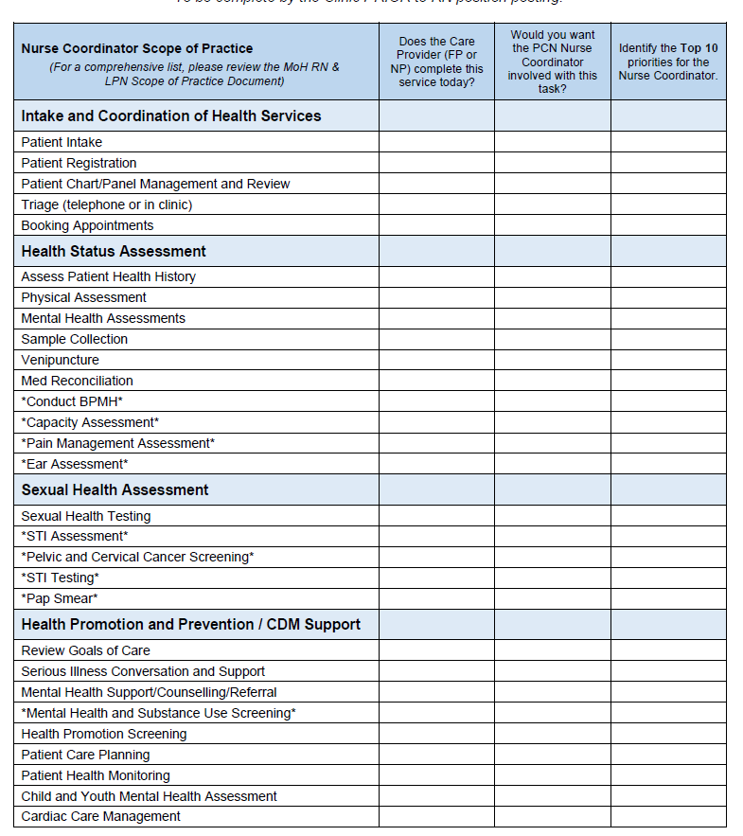
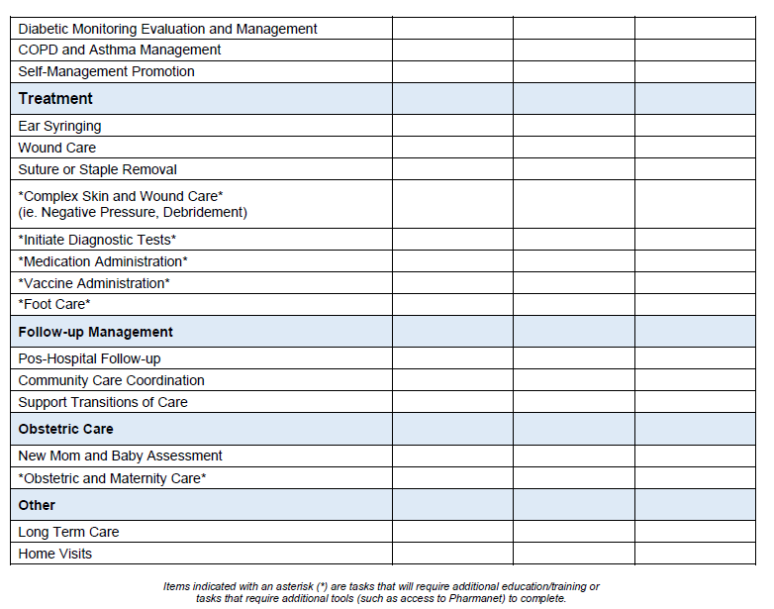

NIP COMPETENCY TRIANGLE
(Source: BCCNM website)
What Legislation and regulations impact my practice?
- Be aware of provincial and federal legal rules and regulations that impact your practice. For example, Ministry of Health, BC Law, Canadian Health Care Acct, Health Professionals Act, etc.
What does my nursing college tell me I can do?
- Review British Columbia College of Nurses and Midwives Registered Nurses practice and standards - scope of practice, practice standards, certified practice, and professional standards. Know what standards, limits, and conditions affect your practice. Certified practice decision support tools and competencies can be found on the Nurse and Nurse Practitioners of British Columbia website.
Does my organization have policies, procedures, and guidelines in place to support my practice and am I following them?
- Know Island Health’s policy, procedures, and guidelines.
- What training, supports and practices do I required to perform m care services? What do I require coaching, mentoring and education in to ensure that I am confident and competent in my practice?

ISLAND HEALTH COURSES
All Allied Health Team Members in the Port Alberni Primary Care Network will need to log into https://learninghub.phsa.ca/Courses to complete Mandatory courses.
All courses marked ‘M’ are mandatory; those marked ‘O’ are optional. This list does not include orientation and training that may be specific to the Primary Care clinic/setting that the staff member is assigned to; that will be developed in collaboration with the clinic/setting and provided separately.
Staff are required to complete all mandatory training by the end of the first month of employment or at the discretion of their health authority manager.
All New Island Health Staff
Course Code | Course Description | Mandatory (M)  Optional (O) | Completed  (Y=Yes)
15898 | New Employee Orientation (NEO) | O

All New Primary Care Network Staff
Course Code | Course Description | Mandatory (M)  Optional (O) | Completed  (Y=Yes)
 | Island Health Primary and Community Care Orientation
23411 | Primary and Community Care Orientation (23411)  Staff will need to submit evidence of completion for the following courses that are included in the Island Health Primary and Community Care orientation course:  - TBC on the Run (course) – 3 hrs  - Social Determinants of Health (course) – 1.5 hrs  - Equipping for Equity (course) - 2 hrs  - Trauma Informed Care (TIC) (course) – 5 hrs | M
 | Primary Care Network – Purpose, Vision, Attributes
N/A | https://gpscbc.ca/what-we-do/system-change/primary-care-networks | M
 | Team Based Care Fundamentals
N/A | https://bcpsqc.ca/resources/team-based-care/ | M
 | Annual Recertification
14697 | Confidential Information Management (CIM) Code of Practice (module) | M
11484 | Code Red (module) | M
15336 | Code Yellow - Missing Persons (module) | M
15335 | Code Black - Bomb Threat (module) | M
 | Safety
11925 | Infection Control and Hand Hygiene for Island Health (module) | M
15338 | Code Grey - System Failure (module) | M
12047 | Code Green - Evacuation (module) | M
15337 | Code Brown - Hazardous Spill (module) | M
14992 | Restricted Access and Lockdown (module) | M
6109 | British Columbia Patient Safety & Learning System (BC PSLS): Patient Safety (module) | M
15340 | Highlights of Island Health’s Violence Prevention Policies (module) | M
7558 | Provincial Violence Prevention for Medium and High Risk Departments - 8 Modules (course) | M
14956 | Violence Prevention - PVPC Classroom (in person) | M
 | Clinical Care & Skills
11053 | Fall Prevention and You (online) (module) | M
16397 | Code Blue - Cardiac Arrest (module) | M
11044 | Chronic Disease Self-Management (module) | M
11716 | Mental Health Act – Island Health (module) | M
16554 | Orientation to Suicide Risk (module) | M
23000 | Infants Act: Determining Consent for Treatment and Information Sharing (module) | M
14812 | Abuse, Neglect or Self-Neglect of Vulnerable or Incapable Adults – Part 1 (module) | M
12395 | ReACT: Act on Adult Abuse and Neglect – It’s Your Duty (module) | M
11955 | Advance Care Planning and Health Care Consent (module) | M
7572 | Consent to Care Facility Admissions in BC: A Course for Managers and Assessors (module) | M
12069 | Medical Orders for Scope of Treatment (MOST) (course) | M
 | Person-Centred Care/ Cultural Safety
7859 | Aboriginal Health: For the Next Seven Generations for the Children (module) | M
8141 | Exploring Gender Diversity: for health authority employees (module) | M
N/A | San’yas Indigenous Cultural Safety Training (course) – 8 hrs  (Limited seats for this course. If unavailable, try again at a later date) | M
 | Safety
8300 | IPAC Practices for Direct/Professional Clinical Care Providers (module) | M
 | Technology
13562 | IHealth: Controls Documentation (module) | M

Primary Care Networks (Big Picture)
Course Code | Resource Description | Mandatory (M)  Optional (O) | Completed  (Y=Yes)
N/A | Primary Care Networks | GPSC (gpscbc.ca) | M

Port Alberni Primary Care Network
Course Code | Resource Description | Mandatory (M)  Optional (O) | Completed  (Y=Yes)
NA | Logging in and Navigating Med Access | M
N/A | EMR Orientation Videos - YouTube (Med Access)  Complete Med Access modules as they are relevant to your clinic assignment | M

PATHWAYS
Pathways is a provincial database that provides up-to-date information about specialist wait times, referral processes, and contact methods. Ask your physician/NP for access through their license. For new licenses, please contact Amanda Salvage, PA PCN Administrative Assistant to set up an access key.
Email:
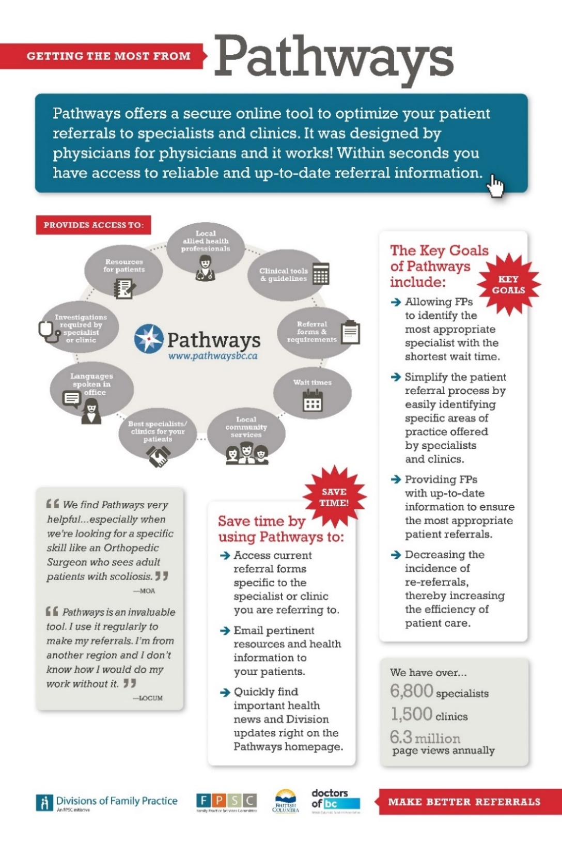

Pathways Training
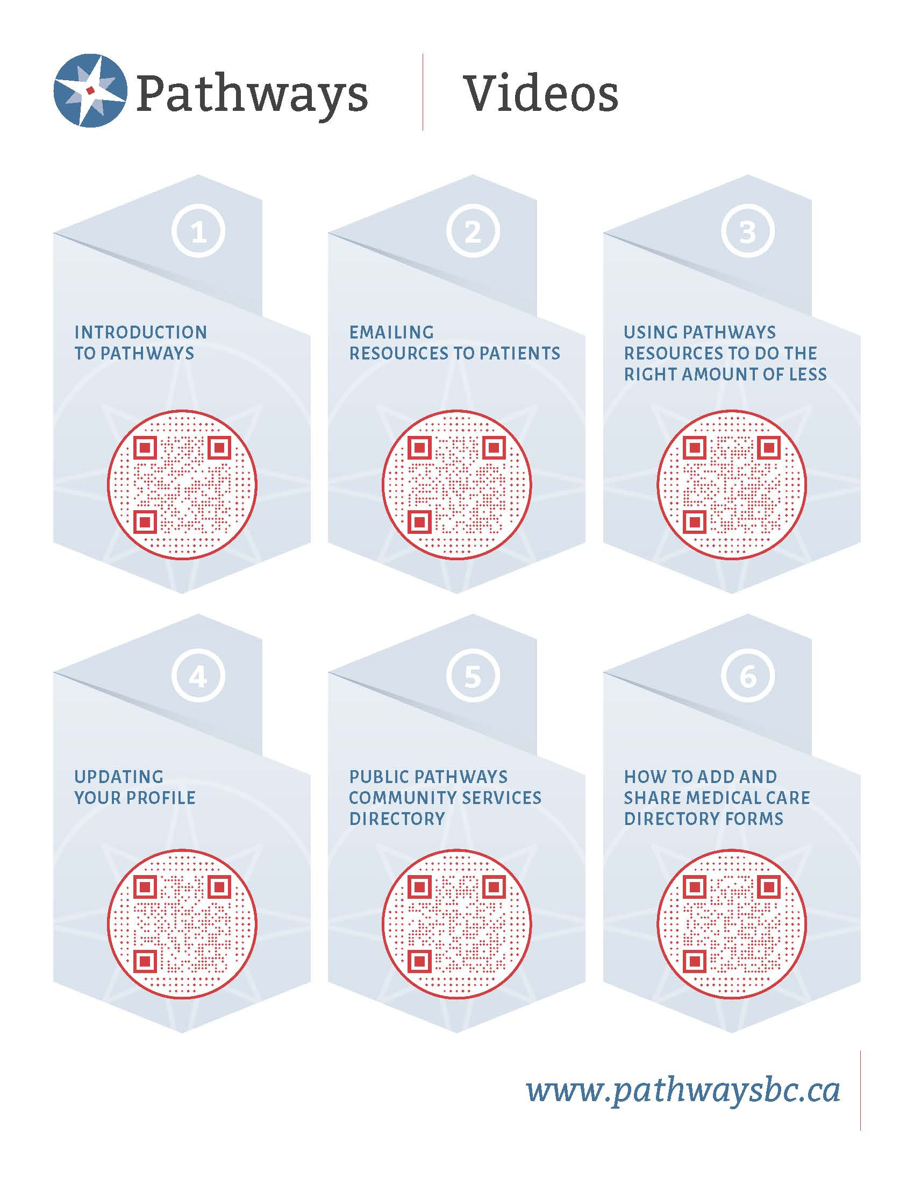

OTHER RESOURCES
Health Gateway | https://www.healthgateway.gov.bc.ca/
BCCNM | https://www.bccnm.ca/RN/ScopePractice/Pages/Default.aspx
RN Scope of Practice | https://www.bccnm.ca/Documents/standards_practice/rn/RN_ScopeofPractice.pdf
Lippincott | https://www.nursingcenter.com/login
Pathways Public Directory | https://pathwaysmedicalcare.ca/
PharmaNet: | https://www2.gov.bc.ca/gov/content/health/practitioner-professional-resources/pharmacare/pharmanet-bc-s-drug-information-network/prime
Health Connect Registry (patient registry for the province) | https://www.healthlinkbc.ca/health-connect-registry
Central Island Division of Family Practice website | https://divisionsbc.ca/central-island
BC Family Doctors Website (billing resources etc.) | https://bcfamilydocs.ca/

QUICK REFERENCE

Hospital
BC Ambulance
911 or
RCMP
911 or
Medaccess EMR Help Desk
1-888-781-5553
Port Alberni Primary Care Network (PA PCN)
PCN Manager:
Change Management:
Administrator:
Island Health Primary Care Manager
Practice Improvement Coach, Doctors of BC

Record of Amendments
Date | Amendment page number/description | Entered By

APPENDIX A: ENCOUNTER COdes

APPENDIX B: ENCOUNTER RECORD AUTHORIZATION

APPENDIX C: APPLICATION FOR BILLING NUMBER

APPENDIX D: MEDACCESS INTRODUCTION

