Shonda Holt
Oceanside pcn

Oceanside Primary Care - Primary Care Clinical Pharmacist

Onboarding Process

Contents
Onboarding Process 0
ACKNOWLEDGEMENTS 3
PROGRAM INTRODUCTION 3
STAKEHOLDERS 3
SUMMARY OF STEPS 4
Step 1 – Recruitment 4
Stakeholders Involved 4
Step 1 – Process Overview 4
Process Detail Steps 5
Step 2 – Expression of Interest 5
Stakeholders Involved 5
Step 2 – Process Overview 5
Discovery Meeting 5
Clinic Eligibility Requirements 5
Step 3 – Site Preparation 6
Stakeholders Involved 6
Step 3 – Process Overview 6
Meet with Clinic Staff 6
Information Sharing Agreement (ISA) 7
Island Health Service Agreement 7
Oceanside PCN Membership 7
OH&S Walkthrough/Hazard Assessment 7
Step 4 – Orientation, Training & Development 7
Stakeholders Involved 7
Step 4 – Process Overview 7
Orientatio 7
Clinic Overhead 8
Step 5-Monitoring and Evaluation 8
Stakeholders Involved 8
Monitoring 8
Evaluation 8
appendices 9
Appendix A: EOI Form 9
Appendix B: GP Supporting Documentation 11
Appendix C: Hazard Assessment Sample Report 12
Appendix D: Agenda for Discovery Session 13
Appendix E: Agenda for Clinic Meet and Greet 13
Appendix F: Job Description 14
Appendix G: Primary Care Clinical Pharmacist (PCCP) On-boarding Checklist 17
Appendix H: Frequently Asked questions 18

ACKNOWLEDGEMENTS
The Central Island Division of Family Practice (The Division), Vancouver Island Health Authority (Island Health), Qualicum First Nation and Snaw-naw-as First Nation (collectively, the PCN Members) have jointly established the Oceanside Primary Care Network (PCN). The PCN is also supported in an advisory capacity by FNHA, the PCN Manager, Division Staff, and the local Island Health Managers.
The Ministry of Health (MoH) has contracted UBC for three years to use their experience to integrate, train and support the pharmacists into team-based primary care with the support of the Island Health local manager.

Provider Eligibility Requirements
- Member provider has a full service family practice offering longitudinal care
- Will identify a physician and administrative PCN lead
- Member provider will participate in:
  - working groups (funded through Division funding)
  - Patient Experience Survey (Practice Support Program)
  - Panel Management with the Practice Support Program (PSP), panel clean up and ongoing maintenance every 6-12 months.
- Make time to engage in team development and processes required to implement a team-based care model and work within a team
  - Central Island Division of Family Practice’s Patient Medical Home and Primary Care Network initiatives as applicable (i.e. team-based care orientation/educational opportunities; reporting/evaluation; patient attachment imperatives)
- Member provider must ensure a respectful workplace code of conduct is in place
- Commit to:
  - Using the Health Data Coalition (HDC) to support reflective practice (if available with EMR)
  - Ensuring all team members complete team-based care training that is culturally safe, trauma informed, and support them in doing so
  - Sharing data and metrics for quality improvement and evaluation
  - Working with other clinics/teams to coordinate “flow” of shared team members and share learnings
- Make a minimum 12-month commitment to the PCN Initiative. The commitment requires 3 months’ written notice of the clinic’s intent to terminate its PCN involvement
- Member provider must demonstrate active implementation of the attributes of the Patient Medical Home (see attachment)
- EMR
It is also highly preferable that clinics seeking to join the Oceanside PCN have first been assessed in terms of PMH capability, which significantly enables integration within a PCN.

Note: If you require a Panel Clean-up the Practice Support Program (PSP) Coordinator assist in the process.

Membership
When joining the PCN, members can decide which level of participation they prefer. Each level of membership comes with different benefits and expectations for members.
 | Tier 1 | Tier 2 | Tier 3
Stay informed about PCN news and get connected to other members
Consult with or refer to allied health resources located anywhere in your PCN neighbourhood
Physically accommodate new PCN allied health (shared with other PCN members) or GP/NP resources within your clinic

Member Responsibilities | Tier 1 | Tier 2 | Tier 3
Work towards PMH attributes (*only applies to PMHs)
Complete the PMH assessment provided by GPSC
Actively partner in team-based care
Participate in cultural safety training, trauma informed, & change management training to support the introduction of new team members
Regularly provide data for PCN monitoring & evaluation, including patient experience surveys
Work collaboratively with the enhanced provincial Health Connect Registry if PCN resources require attachment
Ensure adequate space to support an interprofessional team member

Supporting Team-Based Care
Team-based Care is a new model of care known to provide an overall benefit to patients and providers through improved coordination between primary care services when compared to fractioned models of care. The Oceanside PCN is dedicated to supporting the development and implementation of team-based care with participating clinics. Team Based Care provides health services to individuals, families, and/or their communities by care providers. Care givers work collaboratively with patients (according to their individual preferences) to accomplish shared goals to achieve coordinated high quality care that is patient centered.
We know that the main enablers of team-based care include:
- Agreed upon definitions of a successful team
- Shared values and principles
- Role Clarity
- Co-location where possible
- Effective communication
- IT Systems
- Leadership
- Training and team development
- Continuous measurement as a guide for continual improvement through feedback.

We are committed to implementing an onboarding and learning plan and the necessary supports to ensure that participating teams can be successful and are supported. This will include individual and clinic location orientation sessions as well as team learning opportunities, such as cultural safety and humility learning and team process mapping to name a few. As teams develop you can expect that we will be reaching out to determine change readiness and your team learning needs.

Supports for Participating Teams
What does it mean to participate in the Oceanside PCN? In addition to ensuring everything we do is culturally safe and embraces equity as a guiding principle, a core ethos of the PCN is that it is to be built by clinicians, for clinicians, maintaining the patient interest at the heart of all decisions. To do that, we, the core PCN program team, need constant and regular engagement and involvement from our entire network of clinicians, for which funding is being provided.
Participating care teams across the PCN will be supported by the PCN Manager, Change Management Lead, PCN Assistant and GPSC Practice Support Program (PSP). Clinical teams will also be funded for time spent in PCN planning, development, implementation, and quality improvement related activities (remember, this is by clinicians, for clinicians).

PROGRAM INTRODUCTION
The Oceanside PCN is working with the UBC Faculty of Pharmaceutical Sciences, Vancouver Island Health Authority, and Family Practice Clinics to introduce a Primary Care Clinical Pharmacist (PCCP). Oceanside PCN will have one PCCP that will focus on patient care services to complex patients. PCCPs will work directly as part of a care team in the ongoing care of patients with complex conditions.
Working as part of a care team, PCCPs will:
- Provide comprehensive medication management services focused on the on-going care of adult patients with complex conditions to prevent and resolve medication-related problems, educate the patient about their medications, help remove barriers to patients in following prescription advice, and help patients achieve better health outcomes.
- Establish linkages with other health authority pharmacy staff, community pharmacists and other members of the inter-professional team as appropriate to ensure continuity of care for patients.
- Create a record of working notes in UBC’s secure, regulated electronic medical record (EMR) and action-oriented, summary notes in the clinic’s EMR.

PCCP and PCN Integration
The PCCP will work in a blended hub and spoke model.
  - Care for patients referred from multiple clinics, case conferences, etc.
  - The central site for PCCP referrals will be the Oceanside Health Centre. This location does not have the capacity for in-person patient visits but will provide a workspace for virtual appointments.
  - The PCCP will be co-located in approved clinics on a schedule determined by individual clinics and the PCN.
    - Virtual and in-person patient care options available

The process outlined in this document is for providers that want to integrate the PCCP into their practice using Team-Based-Care.

PCCP Service Types and Modalities
- Initial, follow-up, recall
- 1:1 visit in clinic, telephone, telehealth
- Case conference (with or without patient)
- Rounds (review of day’s case load, multiple patients)
- Immunizations

Patients can be seen one-on-one by the PCCP or join a regularly scheduled PCP appointment.

The PCCP Work Day
A PCCP is typically scheduled for a maximum of 60% clinical (direct patient care) time. The remainder of the time is for duties to support patient care including clinical prep and follow-up, travel between sites, interactions with team members, team and patient education and continuous quality improvement.
The following document has been created to aid in the standardization of the onboarding process.

STAKEHOLDERS
- Central Island Division of Family Practice
- Vancouver Island Health Authority
- Qualicum First Nation
- Snaw-naw-as First Nation
- First Nations Health Authority
- Oceanside PCN Steering Committee
- Oceanside PCN Manager and Change Management Lead
- Island Health Manager
- Oceanside Physicians and Nurse Practitioners
- Registered Nurse
- UBC

SUMMARY OF STEPS
Step 1 – Recruitment
Step 2 - Expression of Interest (EOI)
Step 3 - Site preparation (If required)
Step 4 - Orientation, training & development
Step 5 - Monitoring and evaluation

Step 1 – Recruitment

Step 1 –Overview
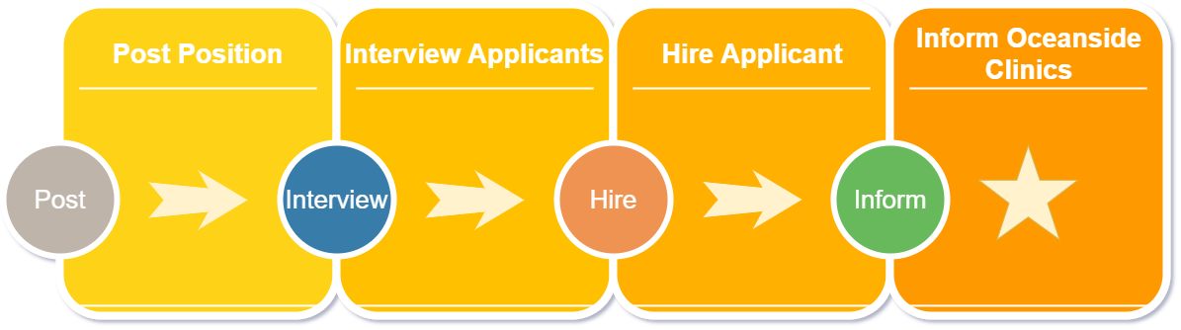

Once the Ministry approves the placement of a PCCP in the Oceanside PCN, the recruitment process can begin. The Island Health Pharmacy Manager of Clinical Pharmacy Programs will post the PCCP position.
A hiring panel will be established with representation, including:
- The PCN, who knows the community and the other providers the best;
- UBC, who brings clinical expertise to the program; and,
- The regional health authority pharmacy department, who will be the PCCP’s employer.
The PCN will participate on the selection panel, provide feedback and make recommendations to the health authority.
The health authority will post the position in the same way that other allied health professions within the PCN are posted. The posting will be advertised internally and externally simultaneously. Candidates will submit applications through the usual health authority process, and the hiring panel will assess candidates.
Once a candidate is selected a meet and greet with clinic teams will be arranged for those interested.

Step 2 – Expression of Interest

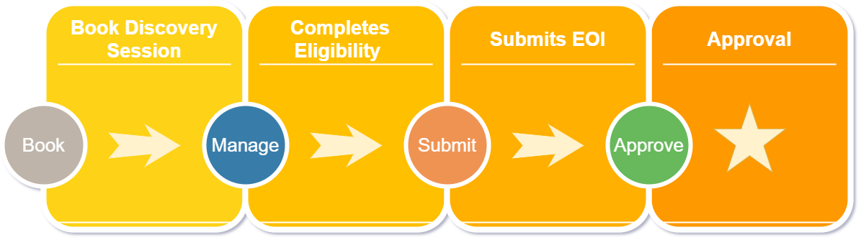
Step 2 –Overview

Discovery Meeting
A discovery meeting is recommended before an EOI is submitted to discuss the onboarding process, orientation, hours, OH&S walkthrough (if required), referral process, and the role of the Division, UBC, and Island Health. This ensures that a fulsome EOI is submitted and an efficient approval process. See Appendix B.

Step 3 – Site Preparation

Step 3 –Overview
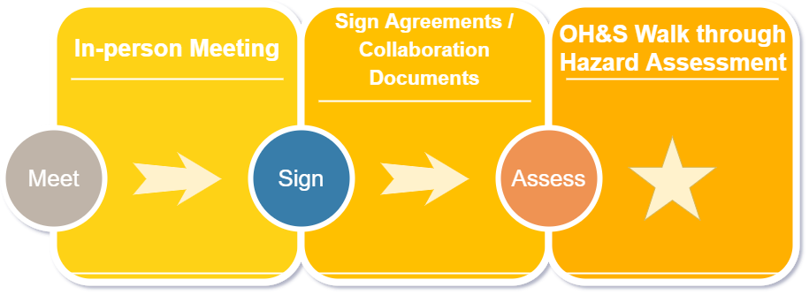
Before the PCCP begins work in a clinic, various site preparation activities must take place. These include:
- Meet with clinic staff – 1 hr
- Sign collaboration documents
- PCCP workflow assessment – 1 hr

Meet with Clinic Staff
An in-person meeting with the Oceanside PCN Manager, Island Health Pharmacy Manager, and Clinic Staff (or Provider Champion) is scheduled to discuss what they can anticipate for Step 3 and beyond. This meeting is expected to take 1 Hr. and will provide the clinic with an overview of the Island Health Activities, Workspace & Workflow Optimization, and PCCP Scope. For a sample agenda and suggested additional topics, see Appendix C.

Information Sharing Agreement (ISA)
The host provider will sign the ISA after the initial meeting with the clinic staff. The purpose of the ISA is to establish a data-sharing agreement. The agreement makes it the responsibility of the host clinic to provide clinical documentation in the event of a performance-related concern and/or request. In the event of a performance-related concern, the Oceanside PCN Manager and the Island Health Pharmacy Manager will work together to address the concerns raised.

Island Health Service Agreement
The Island Health Service Agreement is not required as the PCCP’s main office is at Oceanside Health Centre.

Oceanside PCN Membership
When joining the PCN, members can decide which level of participation they prefer. Each level of membership comes with different benefits and expectations for members.
 | Tier 1 | Tier 2 | Tier 3
Stay informed about PCN news and get connected to other members
Consult with or refer to allied health resources located anywhere in your PCN neighbourhood
Physically accommodate new PCN allied health (shared with other PCN members) or GP/NP resources within your clinic

Member Responsibilities | Tier 1 | Tier 2 | Tier 3
Work towards PMH attributes (*only applies to PMHs)
Complete the PMH assessment provided by GPSC
Actively partner in team-based care
Participate in cultural safety training, trauma informed, & change management training to support the introduction of new team members
Regularly provide data for PCN monitoring & evaluation, including patient experience surveys
Work collaboratively with the enhanced provincial Health Connect Registry if PCN resources require attachment
Ensure adequate space to support an interprofessional team member

Step 4 – Orientation, Training & Development

Step 4 –Overview

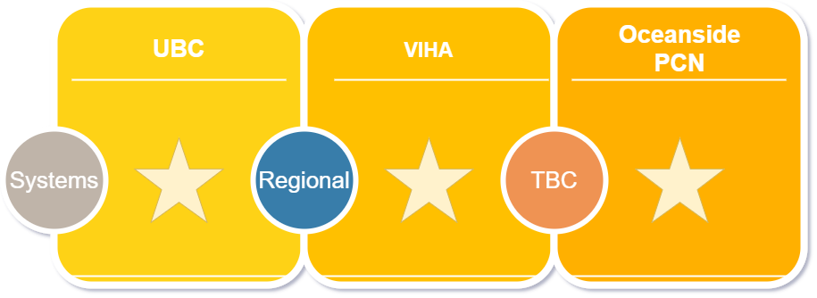
Orientation
Island Health, UBC and the PCN Manager will work together to develop a comprehensive orientation for the PCCP.
The goal of orientation is to ensure that the PCCP is integrated into the care team and understands the workflows. The Health Authority will address regional orientation processes. UBC will provide ongoing training and support for each PCCP (including quality assurance, operational systems, administration and support, coordination with communities and other infrastructure) to optimize the PCCP’s clinical effectiveness.
See Appendix ___ for a detailed orientation schedule.
Learning Lab

Clinic Overhead
The PCCP’s overhead will flow to Island Health. Developing the logistics to provide supplies for the PCCP require collaboration with Island Health.
To help the clinic cover extra costs, the PCN is providing $19,350/year to cover expenses such as licenses to access PharmaNet, additional EMR licenses, supplies purchasing (computer, workstation, and/or a desk). Clinics will invoice Island Health for expenses incurred.

Step 5-Monitoring and Evaluation

Monitoring
Oceanside PCN Manager will meet with participating provider champions or their designate regularly to facilitate discussion around what is going well, what isn’t and how we can do things differently. It also allows providers the opportunity to collaborate and share best practices.
The Oceanside PCN has also created a ____ (monthly?) online feedback form where participating members can write down their thoughts, frustrations, questions, and/or feedback, and to have someone from the Oceanside PCN or other members reply anonymously.

Evaluation
The Oceanside PCN is working collaboratively with physicians, patients, practice staff, and allied health providers to collect information and guide how the PCCP is affecting day to day work and patients’ access to their primary care provider. This will be collected on an ongoing basis through surveys, formal and informal interviews. The results will be shared on an ongoing basis.

APPENDICES

Appendix A: EOI Form

Primary Care Network: Pharmacist
Expression of Interest Form
Please email completed form to sholt@divisionsbc.ca
Clinic Information
Clinic Name: enter text.
Principle Setting of Clinic: Choose
Clinic Interest
Please explain your clinic’s interest in having a pharmacist join your team:enter text.
Please outline how you will integrate the pharmacist into your workflow: enter text.
Which EMR do you currently use? Enter text.
What is your clinic’s approximate panel size? enter text.
Of your total panel size, what proportion do you estimate fit within the following categories? enter text.

- deprescribing
- Patients not at targets (ex: fluctuating INRs, Elevated A1C, BP not at target despite multiple medications etc)
- Polypharmacy
- questions around drug therapy/safety
- adherence strategies
- Complimentary & Alternative Medicines (CAM)

Number of healthcare providers working in your clinic:

- Physician/NP days per week enter text.
- Registered Nurse/LPN enter text.

Provider Lead
Nominated Provider Lead:
First Name enter text. Last Name enter text. Email: enter text. Phone # enter text.
Has he/she completed/started the GPSC Panel Development Incentive? Choose.
Signature of provider lead:_________________________
Date: date.

Appendix B: Agenda for Discovery Session
Agenda Item | Lead | Time
- Introductions
- Onboarding process
- Orientation
- Role of the PCCP
- PCCP Schedule
- Workplace Health Recommendations
- Role of the Division and Island Health

Appendix C: Agenda for Clinic Meet and Greet
Agenda Item | Lead | Time
- Introductions
- Visioning (yesterday/tomorrow)
  - What changes need to be made to get to future state?
  - Workflow
  - Case finding
- Workspace
  - Workspace
  - Workplace Health Recommendations
- Communication
  - Within the team
  - To patients
- Roundtable/ Wrap up

Appendix D: Orientation

Appendix E: Information Sharing Agreement

Appendix F: Job Description
Job Title: Primary Care Clinical Pharmacist
Facility: Various Community and Primary Care Work Sites (may include primary care physician offices and other non-HA owned/operated facilities/sites/clinics)
Department: Pharmacy
Reports to: Manager (or designate)
Bargaining Unit: HSA Job Code: 30496
Classification: Grade II (g), Pharmacist (MA) Grade II
JOB SUMMARY: In accordance with established vision and values of the organization and situated within identified primary care network locales, this position provides clinical pharmacy services to patients of the primary care network. As a member of an interprofessional team this position works directly with patients to identify and resolve actual and potential drug therapy problems through provision of comprehensive medication management.
TYPICAL DUTIES AND RESPONSIBILITIES:
- Identifies and resolves actual and potential drug therapy problems in collaboration with the patient and other members of the primary health care team.
- Provides comprehensive medication management and pharmaceutical care by monitoring the medical condition(s) and ongoing drug therapy for effectiveness, adherence, adverse reactions, drug interactions and therapeutic, chemical and laboratory incompatibilities. Communicates pertinent findings, recommendations and plans to the patient and appropriate healthcare practitioners.
- Consults with patients and members of the primary care health team to develop patient-specific therapeutic plans based on chart review, patient information and assessment of clinical responses.
- Maintains appropriate documentation in the health record in accordance with organizational standards and practices as required.
- Uses appropriate resources to support professional practice and patient care including those available through provincial programs, such as academic detailing, optimal drug use initiatives, opioid stewardship and de-prescribing.
- Establish linkages, as required, with health authority, community pharmacy services and other relevant community services to support continuity of care for patients.
- Provides drug information, consultative and other support services to medical, nursing, pharmacy and other primary care health team members by communicating with them on drug related issues, questions and patient specific therapeutic regimens.
- Conducts patient counselling and education regarding drug therapy.
- Provides in-service education to the primary health care team where appropriate.
- Provides instruction and supervision to students such as University Pharmacy Undergraduates and Pharmacy Residents.
- Participates in various committees as appointed, to provide guidance and advice on drug therapy
- Participates in quality improvement activities through reviewing current practice, identifying actual or potential problems and recommending and evaluating modifications.
- Maintains workload records and metrics as required.
- Participates in a variety of programs such as Patient Safety and Drug Reaction Reporting by collecting and compiling relevant data as applicable.
- Shares the responsibility for orientation of new personnel and acts as a role model.
- Maintains a working knowledge of PharmaCare policies and procedures.
- Performs other related duties as required.

QUALIFICATIONS:
Education, Training & Experience
Current registration with the College of Pharmacists of British Columbia and a minimum 2 years recent, related patient care experience, ideally in a team based primary care setting or equivalent. A valid Class 5 driver’s licence and access to a personal vehicle for business related purposes.
Skills & Abilities
• Assessment and Treatment: Demonstrated ability to complete initial and ongoing patient assessments (clinical and diagnostic reasoning) through appropriate/prescribed technical, therapeutic, safety type interventions.
• Teaching: Ability to teach patients and others both one-on-one and in groups.
• Knowledge Integration: Integrates best practice and current research evidence to support professional practice decisions and actions.
• Communication: Demonstrated ability to communicate effectively with patients, families, the public, medical staff and members of the interdisciplinary team using verbal, written, computer communication means. Ability to effectively apply conflict resolution skills.
• Critical Thinking: Demonstrated ability to integrate and evaluate pertinent data (from multiple sources) to problem-solve and make decisions effectively. Applies the problem-solving process demonstrating critical thinking and decision-making skills using a systems approach.
• Human Caring and Relationship Centered Practice: Ability to promote patient-centred care that demonstrates care for and with patients and families, sensitivity to diverse cultures and preferences, patient advocacy and social justice concerns.
• Management: Demonstrated ability to organize work, set objectives and establish priorities. Manages time and resources, implements activities to promote cooperation among the interprofessional team and collaborates across disciplines.
• Leadership: Promotes staff morale, engagement and empowerment. Demonstrates creative planning for change and innovation, implementation of policies or other protocols, and ongoing professional development of self and others.
• Teamwork: Demonstrated ability to foster teamwork and a commitment to excellence in the provision of patient care.
• Equipment: Demonstrated computer skills including the use of Electronic Health/Medical Records and Windows based programs. Demonstrated data analysis skills including appropriate data analysis and reporting tools. Demonstrated ability in the use of e-mail and word processing. Ability to operate other related equipment as required in the specific practice area.
• Physical ability to perform the duties of the position.

Appendix G: Primary Care Clinical Pharmacist (PCCP) On-boarding Checklist
Version: 2, Updated: August, 2020
Administration (prior to start date):
- Clinical Instructor appointment with UBC
  - Includes access to UBC library
- Account set up
  - UBC CWL (campus wide login)
  - Oscar EMR
  - Clinic VPN
  - Microsoft Teams/One Drive
- Technology set up
Training (started in the first week and completed as soon as possible):
- Standard Health Authority training that includes the following (and will not be repeated by UBC):
  - New worker safety orientation
  - Respectful work environment (preventing and addressing bullying and harassment)
  - Workplace violence prevention
- UBC-specific training
  - Privacy and Information Security Fundamentals (Part 1 and 2)
  - Conflict of Interest & Commitment
  - Use of UBC equipment
  - Use and Security of UBC Electronic Information and Systems
  - UBC Canvas orientation (Pharmacists Clinic Onboarding Modules are here)
- Clinic-specific training
  - Read: A White Paper on Team-Based Primary Health Care in British Columbia- Context and Opportunities for Pharmacists
  - Take: San'yas Indigenous Cultural Safety Training
  - Microsoft Teams/OneDrive orientation
  - Oscar Clinician Training Manual/Oscar EMR training videos/Oscar EMR test cases
  - Pharmacists Clinic Onboarding Modules
  - Shadow (virtually or live) Pharmacists Clinic team member
  - Integrated Quality Assurance (Clinic Continuous Quality Care CQC program)
  - Register for injection training (if not already obtained)
  - Familiarize with MOA procedures
- PCN-specific orientation
  - As per PCN and GPSC Care Team Member Training and Orientation Checklist

Appendix H: Frequently Asked questions
A. Overview
- What is the Pharmacist in Primary Care Network program?
This program will see 50 primary care clinical pharmacists (PCCPs) embedded within primary care networks (PCNs) throughout B.C. The first 20 PCCPs will be hired and onboarded by September 2021; onboarding for the remaining 30 will begin in October 2021. The program is being led by the University of British Columbia’s Faculty of Pharmaceutical Sciences (UBC).

- What is the role of the PCCP?
As part of the care team, PCCPs will work directly as part of a care team in the on-going care of patients with complex conditions to prevent and resolve medication-related problems, educate the patient about their medications, and help remove barriers to patients in following prescription advice. PCCPs will use their specialized knowledge to help patients achieve better health outcomes and a higher quality of life. In general, the PCCP will:
- Provide comprehensive medication management services focused on the on-going care of adults with complex medical conditions.
- Establish linkages with other health authority pharmacy staff, community pharmacists and other members of the inter-professional team as appropriate to ensure continuity of care for patients.
- Create a record of working notes in UBC’s electronic medical record (EMR) and action-oriented, summary notes in the clinic’s EMR.

Further information can be found in the standardized provincial job description (Appendix _) which has been developed in consultation with the Health Employers Association of BC and the regional health authorities.

- What is the role of UBC?
For the past six years, UBC Faculty of Pharmaceutical Sciences (UBC) has been developing a model of delivering pharmaceutical care to patients in primary care at the UBC Pharmacists Clinic. The Ministry has contracted UBC for three years to use their experience to integrate, train and support the 50 pharmacists into team-based primary care and conduct an evaluation of the impact on patient care and the health care system. At the end of the three years, UBC will transition the program to another entity to manage.

B. Readiness / Hiring
- What is the process for getting started if the PCN is ready to onboard a PCCP? What needs to be in place to confirm readiness?

PCNs are asked to notify their Ministry of Health PCN regional manager of their readiness. Readiness means that a PCN has identified the physical location for the PCCP, provided a suitable workspace for the PCCP to see patients, and has a clinical champion (family physician (FP) or nurse practitioner (NP)) available to work with the PCCP.
The first 20 PCCPs will be prioritized among PCN communities currently in year two of implementation. It is possible there may be opportunities to support the implementation of PCCPs in PCN communities in year one of implementation. Your ministry PCN regional manager will work with the PCN to assess readiness. Hiring for the next 30 PCCPs will begin in October 2021.

- How does the hiring process work? Who hires the PCCP?
Once the ministry’s Primary Care Division has approved the placement of a PCCP in the PCN, representatives from UBC and the health authority pharmacy department (with the ministry regional manager where schedules permit) will meet with the PCN manager to confirm readiness and next steps.
A hiring panel will be established with representation including:
- The PCN, who knows the community and the other providers the best;
- UBC, who brings clinical expertise to the program; and,
- The regional health authority pharmacy department, who will be the PCCP’s employer.

Each PCN will be invited to have a representative of their choosing to participate on the selection panel, provide feedback and make recommendations to the health authority.
The health authority will post the position in the same way that other allied health professions within the PCN are posted. The posting will be advertised internally and externally simultaneously. Candidates will submit applications through the usual health authority process and the hiring panel will assess candidates.

- Can UPCCs hire a PCCP?
The program is intended to support integrating pharmacists into the PCN to support longitudinal care needs of patients with complex conditions. In cases where the UPCC is providing longitudinal care, further discussion between UBC and the PCN will be required to ensure suitability.

C. Orientation / Training / Performance Management
- What will orientation look like?
Orientation may look a little different in each PCN but ultimately the health authorities, UBC and the PCN will work together to ensure a comprehensive orientation for each PCCP. The goal is to have the PCCP involved in patient care within a week of their start date.
The PCN will ensure that the PCCP is integrated into the care team and understands the workflows of the specific PCN. The health authority will address regional orientation processes. UBC will provide ongoing training and support for each PCCP (including quality assurance, operational systems, administration and support, coordination with communities and other infrastructure) to optimize the PCCP’s clinical effectiveness.

- Are patients seen one-on-one by the PCCP, or does the PCCP join a regularly scheduled FP or NP appointment?
This will be determined by the workflow of a particular clinic and the needs of patients. PCCPs can provide care to patients in either scenario.
- Will the PCCP make changes to a patient’s existing care plan, and if so, do they notify the team?
Any changes made to an existing care plan would be done in collaboration with the care team. The PCCP works collaboratively as part of the care team and can participate in shared or delegated drug therapy decision-making as determined by team workflows.
- How will community pharmacists work with PCCPs?
Pharmacists working in community pharmacies have on-going relationships with people taking medication for chronic health conditions, and their care contributions are important. These community pharmacists will continue to dispense the patient’s medication(s). PCCPs will have on-going collaborative interactions with community pharmacists in the care of mutual patients.
- Will PCCPs be expected to work in multiple primary care clinics?
The distribution of a PCCP’s time within a PCN will be determined by the priorities of the PCN (which may shift over time) and clinic readiness. Some PCNs may have a PCCP working in one site with one care team, while others may split the PCCP’s time across several sites and teams.
- Will the PCCP document in their own EMR and/or the clinic EMR?
The PCCP will keep detailed working notes in an EMR managed and supported by UBC which has been designed to specifically support a PCCP in solving medication-related problems. A succinct action-oriented summary note will be recorded in the clinic’s EMR in way that works for the needs of the clinic. A privacy impact assessment has been completed to ensure proper information flow between UBC’s EMR system and the clinic’s EMR.
- How will the PCCP access PharmaNet?
Each PCN site (where a PCCP will be physically located) should have access to PharmaNet before the PCCP starts. The PCCP will need to be added to the list of people with PharmaNet access at the worksite. Once specific locations are confirmed, UBC will work with the Ministry of Heath to assist with the PCCP’s enrolment as needed. For more information about PharmaNet access, please see https://www2.gov.bc.ca/gov/content/health/practitioner-professional-resources/pharmacare/pharmanet-bc-s-drug-information-network.
- Who will be responsible for performance management?
As the employer, the regional health authority is responsible for performance management and disciplinary issues. If PCNs have performance related issues, they should communicate these to UBC who will liaise with the health authorities.
- Given lessons learned from COVID-19, will the PCCP be able to provide patient care and case conferencing virtually?

Yes. UBC is prepared to support whatever modality is needed for the PCCP to participate in the care team. From experience, the UBC Pharmacists Clinic, has been offering virtual (telephone and video) patient care and case conferencing appointments since 2014. This experience has shown the feasibility of providing this service virtually if needed. For this program, PCCPs will be physically located at a specific clinic or site but will have the ability to see patients or conference with providers across the PCN virtually as needed, based on the model of care being used by the local PCN.
D. Funding
- How does the overhead for PCCP expenses work?
Similar to other health authority-employed providers, the PCCP’s overhead will flow to the regional health authority. Overhead expenses might include licenses to access PharmaNet via the practice site’s PharmaNet application and additional EMR seat licenses. For additional information on overhead, please refer to the Allied Health Overhead Memorandum of Understanding located on the PCN Toolkit.
- Why are PCCPs being hired in a phased approach?
The ministry funding being provided to UBC to lead, implement and support the program enables 20 PCCPs to be hired in the first twelve months, and 30 PCCPs to be hired in the second 12 months.
- Who is in charge of the PCCP’s pay and benefits?
Health authorities will be responsible for payroll and benefits administration, as well as ongoing human resource management of PCCPs deployed in a PCN, in accordance with applicable collective agreement requirements.
- How many PCCPs will be hired?
Funding for the Pharmacists in PCN program has been committed for three years (from Oct 2020 to Sep 2023) and will enable a total of 50 PCCPs to be integrated into PCNs communities in year one and year two of implementation.
E. Program Maintenance / Evaluation
- What is the availability of qualified pharmacists who can move into these roles? What is the risk that positions will go unfilled?
An increasing number of pharmacists from across BC and Canada are interested in working in team-based primary care. It is expected that these positions will be very desirable roles given the nature of the work and the emphasis on team-based care. Based on input from the ministry, UBC will be reaching out to each PCN deemed ready, to ensure active recruitment is supported.
- Have key performance indicators (KPIs) for the PCCPs been developed/selected and will they be tracked?

UBC has established some preliminary KPIs. In addition, an advisory committee is being established as part of the PCCP program, which will have representation from the ministry, UBC, health authorities and PCNs. This committee will be able to review and make recommendations regarding the evaluation plans.

