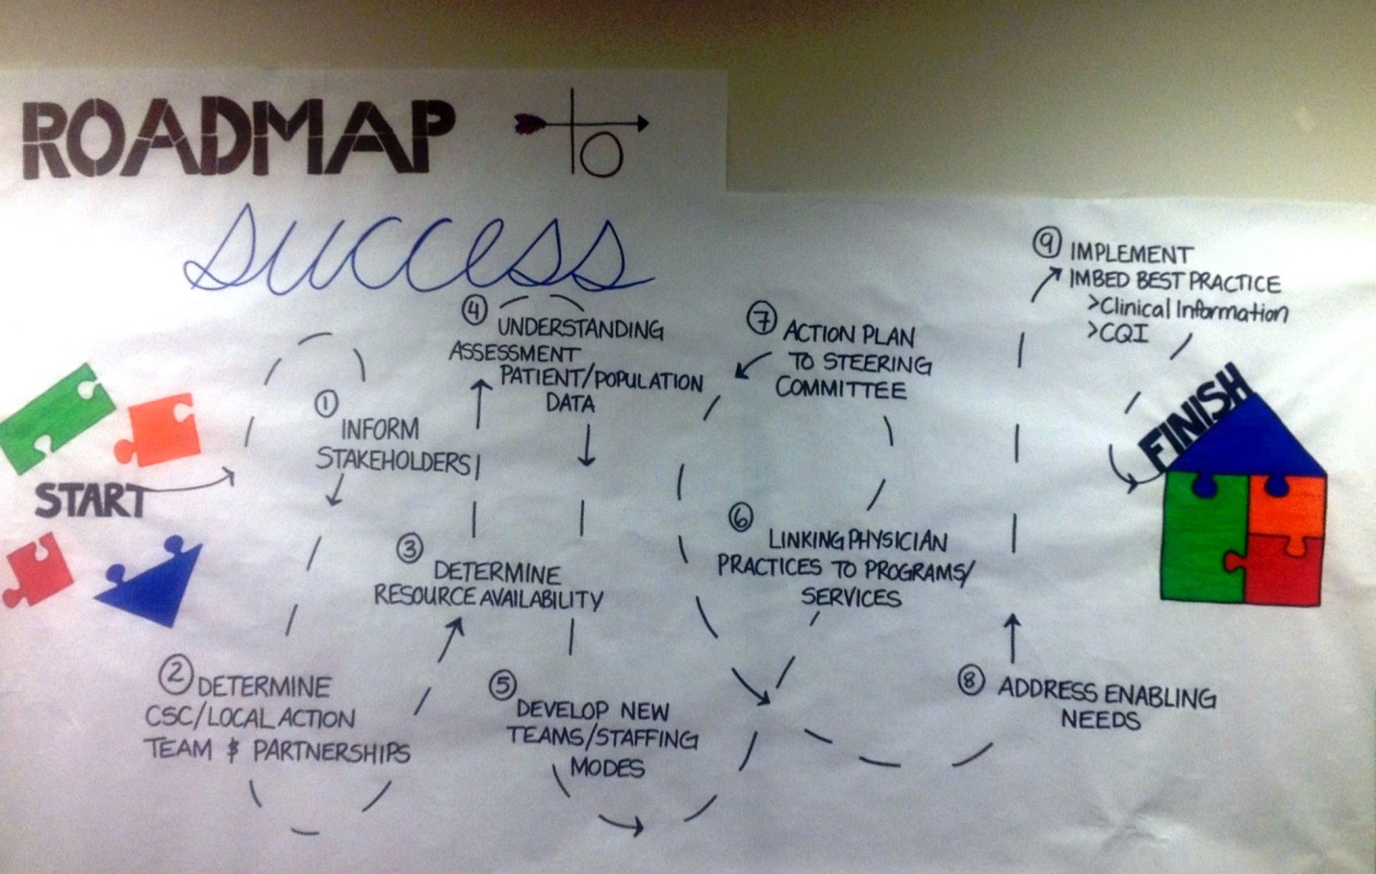
March 31, 2017

Purpose

In response to the Ministry of Health (MoH) policy objectives, the release of the Targeted Operating Model (TOM) and the General Practice Services Committee (GPSC) vision for integrating primary and community care resources in communities, Interior Health (IH) and Divisions of Family Practice (DoFP) have together, outlined a process to guide the integration of Primary and Community Care at the local level.

Creating a working group/local action team from a Collaborative Services Committee (CSC) will allow for the creation of this integrated system at a local level in each community. Strength lies in local leadership, as every community model will have the same principles but the implementation of the TOM may look different depending on resources available, geography and the population served.

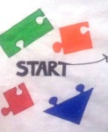
ROADMAP to Success
1: Inform stakeholders
- Provide context and definitions
- Outline outcomes and compelling need for change
- Ensure full diverse membership

2: Determine CSC local partners
- Create local action teams
- Develop Terms of Reference or MoU
- Decide on Resource Team
- Adopt a change model
- Align with Strategic enablers

3: Determine Resource Availability
- Understand existing and/or implemental resources
- Determine Shared Accountability (funding)
- Plan based on realistic asks

4: Understand Assessment Patient/Population Data
- Collection of population, patient and resource data from all partners
- Analysis of data in local patient and population context
- Gap analysis of current resources to be re-designed and those required

5: Develop New Teams/Staffing Models
- Full understanding of the function of team members from: HA; DoFP; Communities health leaders and NGO’s
- Collaborative discussion on what is delivered in; PMH/PCH/CSC

6: Link Physician Practices to Programs/Services
- Considerations: team identification; employment model; funding for TBC; space; contracts; EMR

7: Develop Action Plan
- Seek endorsement from partner organizations as require

8: Address Enabling Needs
- Communication and education to public
- Quality improvement framework
- Evaluation framework
- Data governance, privacy and security
- Clinical information sharing

9: Implement Imbed Best Practice – Clinical Information/CQI

10: Repeat sections dependent on needs of each community

Version 1: June 2017

